Customer Lifetime Value (CLV)
&
Churn Risk Analysis Report

Table of Contents
Chapter 1 Abstract 4
Chapter 2 Introduction 5
Background and Motivation 5
Problem Statement 5
Project Objectives 6
Scope & Operational Boundaries 6
Chapter 3 Data Processing & Database Architecture 8
3.1 Data Ingestion and Consolidation 8
3.2 Star Schema Creation via SQL 9
3.3 Data Quality Audit Execution 12
Chapter 4 Cohort Analysis & Retention Modeling 14
4.1 Customer Cohort Definition & SQL Metric Logic 14
4.2 Matrix Transformation & Percentage Retention Modeling 16
4.3 Cohort Heatmap Visualization Pipeline 17
4.4 Cohort Retention Matrix Findings & Interpretation 18
Chapter 5 RFM Feature Extraction & Distribution Analysis 20
5.1 Observation Window Setup & SQL Metric Engineering 20
5.2 RFM Feature Distribution Analysis 21
5.3 RFM Feature Distribution Summary 22
Chapter 6 RFM Scoring & Business Persona Segmentation 23
6.1 Feature Quantile Scoring Framework 23
6.2 Persona Mapping Logic & Data Persistence 24
6.3 Persona Distribution Visualization & Findings 25
6.4 RFM Persona Breakdown Summary 26
Chapter 7 Target Label Extraction & Master Dataset Engineering 27
7.1 Holdout Target Definition & SQL Synthesis 27
7.2 Master ML Dataset Storage & Export 29
7.3 Churn Validation by Persona & Empirical Results 30
Chapter 8 Predictive Churn Modeling & Pipeline Benchmarking 32
8.1 Training Data Partitioning & Leakage Prevention 32
8.2 Column Transformation Pipeline Setup 33
8.3 Model Training Pipeline & Classifier Benchmarking 34
8.4 Winning Model Export & Artifact Serialization 36
8.5 Model Evaluation Visualizations & Predictor Drivers 37
8.5 Classifier Performance & Feature Weight Summary 39
Chapter 9 Two-Stage Customer Lifetime Value (CLV) Modeling 40
9.1 Active Probability Scoring & Target Data Filtering 40
9.2 Regression Model Benchmarking & Metric Evaluation 41
9.3 Expected 90-Day CLV Synthesis & Artifact Storage 43
9.4 Strategic Visualization & High-Value At-Risk Identification 44
9.5 Predicted 90-Day Expected CLV Across Business Personas 46
Chapter 10 CRM Campaign Mapping & Executive CLV Summary 47
10.1 Vectorized Campaign Routing Logic 47
10.2 Executive CLV & Campaign Summary Aggregation 48
10.3 Priority CRM Export & Master Table Persistence 49
10.4 Comprehensive Project Summary & Business Impact 50
Chapter 11 Business Applications & System Integration 51
11.1 Real-Time CRM Automation Pipeline 51
11.3 ROI & Campaign Budget Optimization 53
Chapter 12 Conclusions & Strategic Recommendations 54
12.1 Summary of Findings 54
12.2 Model Performance & Champion Selection 54
12.3 Limitations 54
12.4 Future Technical Improvements 55
12.5 Executive & Final Reflections 55

Chapter 1
Abstract
In contemporary non-contractual e-commerce environments, anticipating customer attrition and accurately forecasting future financial yield are fundamental challenges for long-term profitability. Traditional retention strategies often rely on static historical segmentation methods that fail to capture dynamic purchasing patterns or anticipate churn risk profiles. This project presents an end-to-end machine learning architecture engineered to predict customer churn and quantify expected 90-day Customer Lifetime Value (CLV) using transactional retail data comprising 5,281 unique customer accounts. By combining heuristic behavioral profiling with multi-stage predictive modeling, the framework replaces reactive marketing tactics with automated, value-tiered customer relationship management workflows.
The system operates within an SQLite database environment. Transactional logs were pre-processed to eliminate operational anomalies, product returns, and missing identifiers, transforming raw records into a structured feature store. This store captures fundamental Recency, Frequency, and Monetary (RFM) metrics alongside categorical persona mappings. To evaluate model performance under realistic operational conditions, a dynamic 90-day holdout observation window was established, defining customer churn as complete inactivity (zero orders) to construct empirical target labels.

Predictive modeling was implemented across two specialized, sequential stages to eliminate target bias:
- Stage 1: Churn Risk Classification: Evaluated across Logistic Regression, Random Forest, and Gradient Boosting models. Logistic Regression achieved optimal probability calibration with a benchmark ROC-AUC score of 0.8058 (74.0% accuracy). Feature importance analysis confirmed raw Recency as the primary driver of attrition risk (25.0% relative importance), followed by historical spend (17.2%) and composite RFM scores (16.5%).
- Stage 2: Conditional Revenue Regression: Evaluated across Ridge Regression, Random Forest, and Gradient Boosting algorithms on active holdout spenders ($N=2,292$). Target variance was stabilized via logarithmic transformation ($\log\left(1+y\right)$). The Gradient Boosting Regressor emerged as the champion model, achieving an $R^{2}$ score of 0.4915, an MAE of $514.35, and an RMSE of $1326.80.

Integrating active probabilities $P\left(\text{Active}\right)=1-P\left(\text{Churn}\right)$ with conditional spend estimates (${\overset{ˆ}{y}}_{\text{conditional}}$) yielded expected 90-day CLV metrics ($\text{CLV}=P\left(\text{Active}\right)×\overset{ˆ}{y}$). Financial aggregation highlights extreme value concentration: the Champions segment commands 67.8% ($1,548,935.77) of projected revenue, averaging $1,115.14 per customer. Secondary tiers such as Loyal Customers ($288,892.77 aggregate CLV) and Promising / Potential buyers ($128,819.75 aggregate CLV) represent key targets for revenue expansion.
To operationalize these predictions, a vectorized campaign engine maps individual accounts to targeted retention strategies based on persona assignments and expected financial yield. Crucially, the pipeline isolated 80 urgent, high-value at-risk accounts ($CLV>\$300$) into an automated export (URGENT_high_value_winback_list.csv). This targeted extraction enables immediate, high-ROI direct outreach and specialized promo codes for valuable accounts, while automatically suppressing low-value or deeply lapsed cohorts to eliminate redundant marketing spend and maximize return on investment.

Chapter 2
Introduction

Background and Motivation
In modern e-commerce ecosystems, customer acquisition costs (CAC) have escalated dramatically due to intense digital competition and shifting ad-platform dynamics. As acquiring new buyers grows increasingly expensive, enterprise sustainability relies heavily on maximizing Customer Lifetime Value (CLV) and driving repeat purchase behavior.
In non-contractual business models- where customers make discretionary purchases without active subscription agreements- identifying when a customer has churned versus when they are simply between purchase cycles is inherently complex. Traditional retention approaches often depend on broad, historical segmentation metrics (such as static RFM scoring) that treat past buying behavior as a direct proxy for future intent. While useful for high-level cohort tracking, these static heuristics fail to anticipate future churn risk or estimate individual expected revenue yield.
Applying predictive machine learning directly to fine-grained transactional data provides a proactive alternative. By modeling individual purchase trajectories, businesses can dynamically forecast attrition probabilities, calculate conditional spending expectations, and deploy targeted marketing interventions well before high-value accounts permanently disengage.

Problem Statement
The primary operational challenge facing retail decision-makers is the inefficient allocation of retention budgets across heterogeneous customer bases. Marketing teams frequently face two core structural inefficiencies:
- Reactive Attrition Management: High-value customers are often recognized as "lost" long after their re-engagement window has closed, making win-back efforts costly and ineffective.
- Uncalibrated Promotional Spend: Universal broad-based promotional campaigns allocate expensive discounts (e.g., flat percentage-off codes) indiscriminately across all tiers. This leads to margin erosion when offered to loyal customers who would buy anyway, while wasting budget on deeply lapsed accounts with negligible expected returns.
Without a unified framework to separate customer churn probability from conditional spending potential, e-commerce organizations cannot accurately prioritize high-value at-risk accounts or suppress low-yield cohorts.

Project Objectives
To resolve these inefficiencies, this project establishes an end-to-end, production-grade analytical pipeline designed to achieve the following core objectives:
- Data Architecture & Cleaning: Ingest raw e-commerce transactional logs into a structured SQLite relational database, filtering returns and administrative anomalies to build an engineered behavioral feature store.
- Heuristic Persona Mapping: Segment the 5,281 unique customer base using quantile-based Recency, Frequency, and Monetary (RFM) metrics to map clear behavioral cohorts (e.g., Champions, Loyal Customers, At Risk).
- Two-Stage Predictive Modeling:
  - Stage 1 (Churn Classification): Train and calibrate classification models (Logistic Regression, Random Forest, Gradient Boosting) on a dynamic 90-day holdout window to predict churn probabilities ($P\left(\text{Churn}\right)$).
  - Stage 2 (Revenue Regression): Train regression models on active holdout spenders to forecast non-zero conditional spending (${\overset{ˆ}{y}}_{\text{conditional}}$).
- Synthesized CLV Estimation: Combine classification and regression outputs into a unified metric: $\text{Expected 90-Day CLV}=P\left(\text{Active}\right)×{\overset{ˆ}{y}}_{\text{conditional}}$.
- CRM Operationalization: Develop an automated, vectorized campaign engine that routes customer predictions into tailored marketing actions and automatically exports high-priority targets (URGENT_high_value_winback_list.csv) to maximize marketing ROI.

Scope & Operational Boundaries
To maintain structural focus and ensure practical deployment feasibility, the operational parameters of this project are defined as follows:
- Target Horizon: All target variables (churn binary flags and financial spending metrics) are evaluated over a standardized 90-day post-observation window ($T_{\text{holdout}}$).
- Business Model Boundary: The methodology applies strictly to non-contractual, transactional retail environments. Subscription-based recurring billing dynamics are outside the scope of this architecture.
- Data Ingestion Boundary: Features are derived exclusively from historical transaction timestamps, invoice numbers, stock quantities, unit prices, and customer identification keys; external third-party demographic or web-traffic telemetry is excluded.

Chapter 3
Data Processing & Database Architecture

3.1 Data Ingestion and Consolidation

To handle multi-year transactional records effectively, raw data was extracted directly from the two sheets of the Excel file (online_retail_II.xlsx): Year 2009-2010 and Year 2010-2011.

Multi-Sheet Integration: Both sheets were loaded into separate pandas DataFrames (df_09_10 and df_10_11) and vertically concatenated using pd.concat(). Setting ignore_index=True re-indexed the combined DataFrame (df_raw), creating a single dataset containing all raw observations across both time periods.

Relational Storage: A connection was established to a local SQLite database (online_retail.db), which initializes automatically upon connection. Using .to_sql(), the uncleaned combined dataset was dumped into a staging table named raw_transactions. Staging raw data in SQL prior to transformation ensures data reproducibility, allows auditability, and offloads analytical queries to a relational structure.
excel_file = "online_retail_II.xlsx"

df_09_10 = pd.read_excel(excel_file, sheet_name="Year 2009-2010")
df_10_11 = pd.read_excel(excel_file, sheet_name="Year 2010-2011")

df_raw = pd.concat([df_09_10, df_10_11], ignore_index=True)
conn = sqlite3.connect("online_retail.db")
df_raw.to_sql("raw_transactions", conn, if_exists="replace", index=False)

3.2 Star Schema Creation via SQL
To transform the flat transactional data into an optimized structure for analytical querying, a Star Schema dimensional model was implemented directly via SQL DDL/DML execution. This decouples transactional facts from entities like customers and products, reducing redundancy and improving analytical performance.
cursor = conn.cursor()

cursor.executescript("""
-- Fact Table: Clean Order Items
DROP TABLE IF EXISTS fact_orders;
CREATE TABLE fact_orders AS
SELECT
Invoice,
StockCode,
Description,
`Customer ID` AS CustomerID,
InvoiceDate,
Quantity,
Price,
(Quantity * Price) AS TotalPrice,
CASE WHEN Invoice LIKE 'C%' THEN 1 ELSE 0 END AS IsCancelled
FROM raw_transactions
WHERE `Customer ID` IS NOT NULL
AND Price > 0;

-- Dimension Table: Unique Customers & Acquisition Context
DROP TABLE IF EXISTS dim_customer;
CREATE TABLE dim_customer AS
SELECT
`Customer ID` AS CustomerID,
Country,
MIN(InvoiceDate) AS FirstAcquisitionDate
FROM raw_transactions
WHERE `Customer ID` IS NOT NULL
GROUP BY `Customer ID`, Country;

-- Dimension Table: Unique Products Metadata
DROP TABLE IF EXISTS dim_product;
CREATE TABLE dim_product AS
SELECT
StockCode,
MAX(Description) AS Description,
ROUND(AVG(Price), 2) AS AvgUnitPrice
FROM raw_transactions
WHERE StockCode IS NOT NULL
GROUP BY StockCode;
""")

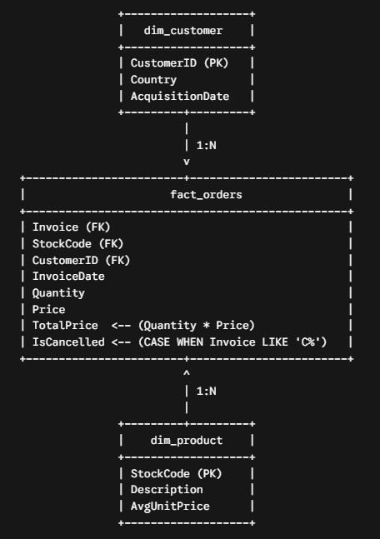
Fact Table: fact_orders
Contains granular transaction line items filtered for data validity.
- Filters: Rows where Customer ID IS NOT NULL and Price > 0 are selected to remove unmapped or invalid price records.
- Calculated Fields:
  - TotalPrice: Computed as (Quantity * Price) to record raw transaction revenue.
  - IsCancelled: A binary indicator calculated using a CASE statement to flag canceled orders (1 if Invoice starts with 'C', otherwise 0).

Dimension Table: dim_customer
Stores unique customer entities alongside their geographical location and initial interaction timeline.
- Attributes: Groups transactions by Customer ID and Country.
- Acquisition Context: Extracts MIN(InvoiceDate) as FirstAcquisitionDate to support downstream customer cohort analysis and customer lifetime value (LTV) calculations.
Dimension Table: dim_product
Represents unique items in the product catalog.
- Attributes: Groups records by StockCode.
- Handling Description Discrepancies: Uses MAX(Description) to select a consistent text label across multiple records.
- Baseline Pricing: Calculates AvgUnitPrice as ROUND(AVG(Price), 2) to record average product pricing across years.

3.3 Data Quality Audit Execution
Before using the Star Schema for downstream analytical tasks or predictive models, a SQL-based quality audit query was executed to measure data retention, flag structural anomalies, and quantify missing values.
audit_query = """
SELECT
(SELECT COUNT(*) FROM raw_transactions) AS Total_Raw_Rows,
(SELECT COUNT(*) FROM raw_transactions WHERE `Customer ID` IS NULL) AS Missing_CustomerID_Rows,
(SELECT COUNT(*) FROM raw_transactions WHERE Invoice LIKE 'C%') AS Cancelled_Invoices_Rows,
(SELECT COUNT(*) FROM fact_orders WHERE IsCancelled = 0 AND Quantity > 0) AS Valid_Sales_Rows;
"""

audit_df = pd.read_sql_query(audit_query, conn)
print("=== DATA QUALITY AUDIT REPORT ===")
print(audit_df.T)

conn.commit()
conn.close()
print("\n[SUCCESS] Step 1 complete. Database initialized and Star Schema created!")

Output:
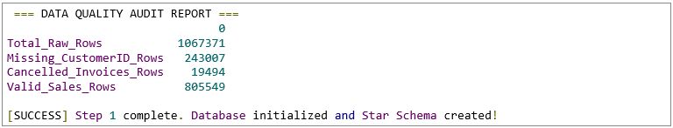

Audit Metrics & Logic:
- Query Execution: pd.read_sql_query() executes the unified audit query against the active SQLite connection and loads the results into a pandas DataFrame (audit_df).
- Transposed Reporting (audit_df.T): Transposes the single-row audit summary into a vertical key-value format for readable console reporting and documentation.
- Audit Metrics Tracked:
  - Total_Raw_Rows: Baseline observation count across both Excel sheets.
  - Missing_CustomerID_Rows: Identifies unmapped records lacking customer identifiers.
  - Cancelled_Invoices_Rows: Quantifies cancellation volume in the raw dataset.
  - Valid_Sales_Rows: Evaluates clean, non-canceled, positive-quantity orders available for revenue and cohort modeling.
  - Transaction Finalization: conn.commit() saves all database schema changes and inserted records permanently, after which conn.close() safely terminates the SQL connection.

Audit Analysis & Key Takeaways
- High Record Retention: Out of 1,067,371 initial raw records, 805,549 observations (~75.47%) passed all data quality filters and were successfully structured into fact_orders for valid non-canceled sales analysis.
- Missing Identifier Impact: The largest source of data filtering stems from unassigned customer identifiers (243,007 rows, ~22.77%). Excluding these rows is necessary for entity-level modeling (such as RFM segmentation and customer lifetime value), as transaction history cannot be reliably attributed without a unique CustomerID.
- Cancellation Profiling: Cancellation events account for 19,494 rows (~1.83% of total volume). Explicitly tagging these transactions using IsCancelled allows downstream workflows to isolate net revenue from gross transactional volume.

Chapter 4
Cohort Analysis & Retention Modeling

4.1 Customer Cohort Definition & SQL Metric Logic
To measure user retention and lifetime engagement patterns, a monthly cohort analysis framework was implemented directly using SQL Common Table Expressions (CTEs) on the SQLite database connection.
conn = sqlite3.connect("online_retail.db")
cohort_df = pd.read_sql_query(cohort_sql, conn)
conn.close()

The underlying SQL logic executes a multi-stage aggregation pipeline across three structured CTE steps:
- Stage 1 (CustomerFirstPurchase): Isolates every unique customer's initial acquisition date (FirstPurchaseDate = MIN(InvoiceDate)), filtering strictly for valid non-canceled sales (IsCancelled = 0 AND Quantity > 0).
- Stage 2 (CohortBase): Truncates both the transactional date (InvoiceDate) and acquisition date (FirstPurchaseDate) to the first day of their respective calendar months (%Y-%m-01). Joining back to fact_orders maps each individual order to its corresponding transaction month (TransactionMonth) and user acquisition group (CohortMonth).
- Stage 3 (CohortIndexCalculated): Computes the relative temporal distance (CohortIndex) between the transaction month and acquisition month in units of elapsed months:
$$CohortIndex=\left({Year}_{tx}-{Year}_{cohort}\right)×12+\left({Month}_{tx}-{Month}_{cohort}\right)$$
- Final Aggregation: Groups observations by CohortMonth and CohortIndex to compute ActiveCustomers using COUNT(DISTINCT CustomerID).
-- Core SQL Logic for Cohort Generation
WITH CustomerFirstPurchase AS (
SELECT CustomerID, MIN(InvoiceDate) AS FirstPurchaseDate
FROM fact_orders
WHERE IsCancelled = 0 AND Quantity > 0
GROUP BY CustomerID
),
CohortBase AS (
SELECT
f.CustomerID,
DATE(STRFTIME('%Y-%m-01', f.InvoiceDate)) AS TransactionMonth,
DATE(STRFTIME('%Y-%m-01', c.FirstPurchaseDate)) AS CohortMonth
FROM fact_orders f
JOIN CustomerFirstPurchase c ON f.CustomerID = c.CustomerID
WHERE f.IsCancelled = 0 AND f.Quantity > 0
),
CohortIndexCalculated AS (
SELECT
CustomerID, CohortMonth,
(CAST(STRFTIME('%Y', TransactionMonth) AS INTEGER) - CAST(STRFTIME('%Y', CohortMonth) AS INTEGER)) * 12 +
(CAST(STRFTIME('%m', TransactionMonth) AS INTEGER) - CAST(STRFTIME('%m', CohortMonth) AS INTEGER)) AS CohortIndex
FROM CohortBase
)
SELECT CohortMonth, CohortIndex, COUNT(DISTINCT CustomerID) AS ActiveCustomers
FROM CohortIndexCalculated
GROUP BY CohortMonth, CohortIndex ORDER BY CohortMonth, CohortIndex;

4.2 Matrix Transformation & Percentage Retention Modeling
Once the SQL aggregation output (cohort_df) was ingested into pandas, the long tabular format was restructured into a 2D matrix representing cohort dynamics across time horizons.
# Pivot Table Creation & Matrix Normalization Snapshot
cohort_pivot = cohort_df.pivot(index='CohortMonth', columns='CohortIndex', values='ActiveCustomers')

cohort_size = cohort_pivot.iloc[:, 0]
retention_matrix = cohort_pivot.divide(cohort_size, axis=0)

Pivoting Structure: cohort_df.pivot() transforms raw query outputs into a grid where rows define acquisition groups (CohortMonth), columns denote months elapsed since acquisition (CohortIndex $0,1,2,…$), and cell values record absolute counts of active customers.
Matrix Normalization: To account for varying initial acquisition volumes per month, relative retention rates were calculated:
- cohort_size isolates column index 0 (CohortIndex = 0), which establishes the total initial baseline cohort size ($100$).
- retention_matrix normalizes all subsequent columns by dividing the pivot table row-wise (axis=0) by cohort_size.

4.3 Cohort Heatmap Visualization Pipeline
A visual audit of the customer retention matrix was constructed using Seaborn and Matplotlib to highlight cross-cohort retention trends, seasonal variations, and churn decay.
plt.figure(figsize=(14, 8))
sns.heatmap(
data=retention_matrix,
annot=True,
fmt='.0%',
cmap='Blues',
vmin=0.0,
vmax=0.5
)
plt.title('Monthly Customer Retention Cohort Matrix (%)', fontsize=14, fontweight='bold')
plt.xlabel('Cohort Index (Months Since First Purchase)', fontsize=12)
plt.ylabel('Cohort Month (Acquisition Group)', fontsize=12)
plt.tight_layout()
plt.savefig("cohort_retention_heatmap.png", dpi=300)
plt.show()

print("[SUCCESS] Step 2 complete. Heatmap saved as 'cohort_retention_heatmap.png'")

Visual Configurations:
- Formatting: Percentage annotations (fmt='.0%') render normalized proportions cleanly in each cell.
- Color Range Mapping: vmin=0.0 and vmax=0.5 cap the colormap scale between 0% and 50%, preventing initial Month 0 values ($100$) from saturating color contrast across subsequent retention months.
- Export: Saves the high-resolution visualization asset (cohort_retention_heatmap.png at 300 DPI) for report inclusion.
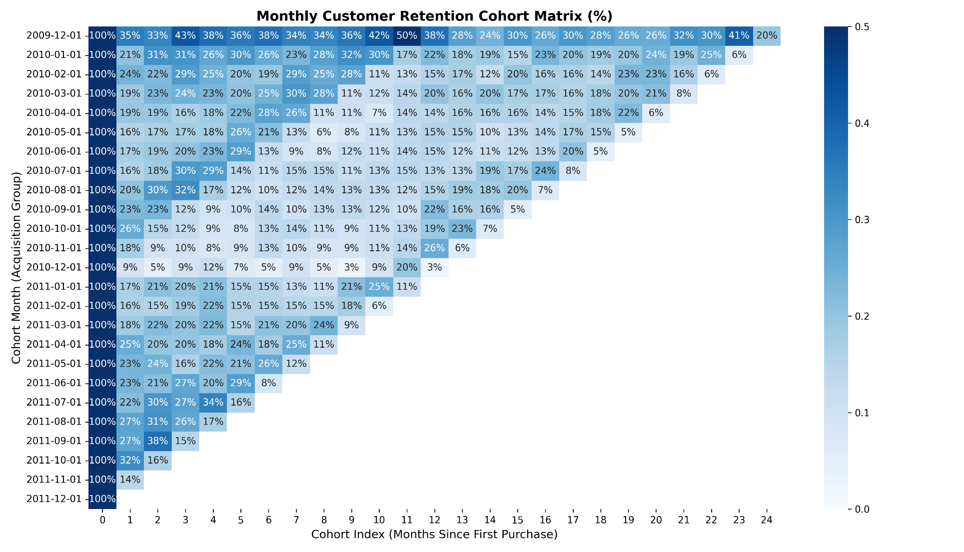
Fig: cohort_retention_heatmap

4.4 Cohort Retention Matrix Findings & Interpretation
The generated heatmap provides a multi-year tracking horizon (Dec 2009 through Dec 2011 across 24 tracking indices) of customer retention behavior.

Key Cohort Retention Metrics Summary
Analysis Angle | Baseline Observation | Key Empirical Metric | Business & Behavioral Insight
Initial Drop-off (Month 1 Churn) | Baseline to Month 1 Decay | 14% – 35% Retention | Immediate repeat purchase rate drops sharply across all acquisition months within 30 days.
Peak Retention Cohort | 2009-12-01 Group | 50% Retention at Month 11 | Dec 2009 cohort exhibits strong long-term stickiness, peaking at 50% repeat buyers in Nov 2010.
Seasonal Re-engagement | November Horizon | +5% to +10% Spike | Multiple cohorts show notable spikes around Cohort Index 11–12, signaling holiday purchasing patterns.
Baseline Stabilization | Months 3 to 18 | 15% – 25% Retention | Beyond initial drop-off, active customer retention stabilizes into a predictable core user base.

Analytical Interpretation & Key Insights
- Immediate Churn Dynamics (Months 0–1): The steepest drop-off occurs between Month 0 and Month 1, with initial repeat rates ranging from 9% (Dec 2010) to 35% (Dec 2009). This confirms that user retention heavily depends on immediate post-acquisition engagement.
- Anchor Cohort Loyalty (Dec 2009): The December 2009 baseline is the strongest cohort, maintaining over 30% retention across most months and peaking at 50% in Month 11 (Nov 2010) due to seasonal demand.
- Q4 Holiday Seasonality: Older cohorts consistently surge during November and December (e.g., Dec 2009 jumps from 42% to 50%; Jan 2010 rises from 17% to 22%). This indicates that dormant buyers predictably return for holiday shopping.
- Long-Term Baseline Floor: Post-drop-off retention stabilizes between 15% and 25% across 12–20 months, reflecting a dependable core customer base driving long-term lifetime value (LTV).
Chapter 5
RFM Feature Extraction & Distribution Analysis

5.1 Observation Window Setup & SQL Metric Engineering
To establish standardized behavioral metrics for downstream modeling, Recency, Frequency, and Monetary (RFM) features were extracted directly via SQL queries.
rfm_df = pd.read_sql_query(rfm_sql, conn)
rfm_df.to_sql("dim_customer_rfm", conn, if_exists="replace", index=False)
os.makedirs("outputs", exist_ok=True)
rfm_df.to_csv("outputs/rfm_features.csv", index=False)
conn.close()

Observation Windowing: A cutoff configuration CTE (CutoffConfig) identifies the dataset's latest transaction date (MAX(InvoiceDate)) and subtracts 90 days (DATE(MaxDate, '-90 days')). Filtering for transactions strictly preceding CutoffDate (f.InvoiceDate < c.CutoffDate) prevents target leakage during predictive modeling.
- Feature Extraction Definitions:
- Recency (R): Measures days elapsed between the customer's final transaction within the observation period and the observation cutoff date:
$$Recency=JULIANDAY\left(Cut0ffDate\right)-JULIANDAY\left(max\left(InvoiceDate\right)\right)$$
- Frequency (F): Computes total distinct valid completed purchase events (COUNT(DISTINCT Invoice)) per customer.
- Monetary Value (M): Calculates net monetary expenditure across all valid non-canceled transactions (ROUND(SUM(TotalPrice), 2)).
-- Core SQL Query for RFM Extraction
WITH DatasetBounds AS (
SELECT MAX(InvoiceDate) AS MaxDate FROM fact_orders
),
CutoffConfig AS (
SELECT MaxDate, DATE(MaxDate, '-90 days') AS CutoffDate FROM DatasetBounds
),
ObservationPeriod AS (
SELECT f.CustomerID, f.Invoice, f.InvoiceDate, f.TotalPrice
FROM fact_orders f
CROSS JOIN CutoffConfig c
WHERE f.InvoiceDate < c.CutoffDate AND f.IsCancelled = 0 AND f.Quantity > 0
)
SELECT
o.CustomerID,
CAST(JULIANDAY(c.CutoffDate) - JULIANDAY(MAX(o.InvoiceDate)) AS INTEGER) AS Recency,
COUNT(DISTINCT o.Invoice) AS Frequency,
ROUND(SUM(o.TotalPrice), 2) AS Monetary
FROM ObservationPeriod o
CROSS JOIN CutoffConfig c
GROUP BY o.CustomerID, c.CutoffDate;

5.2 RFM Feature Distribution Analysis
Using Seaborn and Matplotlib, histogram and Kernel Density Estimation (KDE) distribution plots were generated to assess skewness and variance across the extracted features.
fig, axes = plt.subplots(1, 3, figsize=(18, 5))

# Recency Plot
sns.histplot(rfm_df['Recency'], kde=True, ax=axes[0], color='skyblue')
axes[0].set_title('Recency Distribution (Days)',fontsize=16)

# Frequency Plot
sns.histplot(rfm_df['Frequency'], kde=True, ax=axes[1], color='salmon')
axes[1].set_title('Frequency Distribution (Order Count)',fontsize=16)
axes[1].set_xlim(0, 30) # Capping x-axis for better visibility due to outliers

# Monetary Plot
sns.histplot(rfm_df['Monetary'], kde=True, ax=axes[2], color='green')
axes[2].set_title('Monetary Distribution ($ Total Spend)',fontsize=16)
axes[2].set_xlim(0, 10000) # Capping x-axis for better visibility

plt.suptitle('RFM Feature Distributions & Skewness Check', fontsize=16, fontweight='bold')
plt.tight_layout()
plt.savefig("outputs/rfm_distribution.png", dpi=300)
plt.show()

Output:

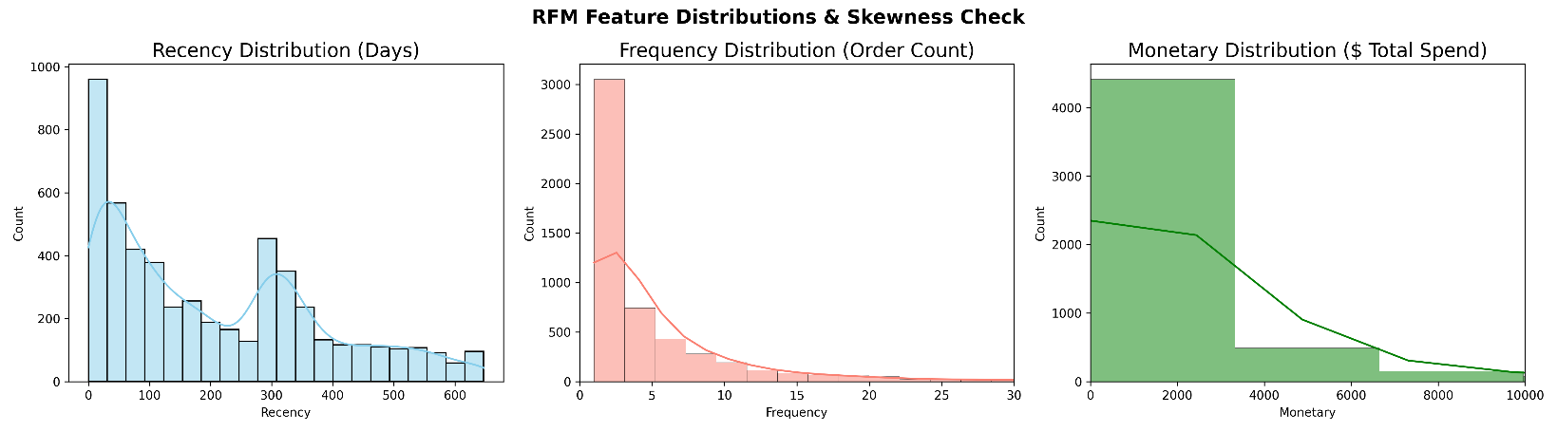
Fig: rfm_distribution

5.3 RFM Feature Distribution Summary
Metric Feature | Customer Scope | Statistical Distribution Profile | Distribution Characteristics & Skewness
Recency (Days) | 5,281 Customers | Bimodal Distribution | Strong left-concentration near 0-100 days, with a secondary peak around 300 days.
Frequency (Orders) | 5,281 Customers | Severely Right-Skewed | Heavy concentration at 1-3 orders; long tail extending past 30 orders.
Monetary ($ Spend) | 5,281 Customers | Severely Right-Skewed | Heavy concentration below $3,000; high-value outlier tail extending beyond $10,000.

Analytical Takeaways & Modeling Implications
- Active Cohort Size: The extraction pipeline successfully isolates 5,281 unique active customers who completed non-canceled purchases prior to the observation cutoff.
- Bimodal Recency Profile: Recency displays a distinct double-peak structure. A primary concentration of active users appears within 0 to 100 days of the cutoff date, alongside a secondary mound centered near 300 days. This secondary peak represents annual seasonal shoppers who purchase exclusively during specific times of the year (e.g., Q4 holidays).
- Extreme Right Skewness (F & M): Both Frequency and Monetary features demonstrate strong positive skewness dominated by low-volume transactional buyers.
  - A majority of customers complete between 1 and 3 transactions.
  - Total customer spending is heavily clustered below $3,000, while a small segment of high-value buyers produces a long upper tail.
- Data Transformation Needs: Because linear and distance-based Machine Learning models (such as K-Means or Logistic Regression) are sensitive to extreme skewness and heavy tails, these features will require logarithmic transformations ($\log\left(x+1\right)$) or robust scaling prior to downstream modeling.

Chapter 6
RFM Scoring & Business Persona Segmentation

6.1 Feature Quantile Scoring Framework
To translate raw numerical RFM metrics into actionable business segments, each customer was assigned quantile-based scores ranging from 1 (lowest) to 5 (highest) using pd.qcut().
# Database Loading & Quantile Scoring Pipeline
conn = sqlite3.connect("online_retail.db")
rfm_df = pd.read_sql_query("SELECT * FROM dim_customer_rfm", conn)

print(f"[INFO] Loaded {len(rfm_df)} customer RFM records from SQLite.")

# Quantile Scoring Logic (1 to 5)
# Recency: Lower days -> Higher score (5 to 1)
rfm_df['R_Score'] = pd.qcut(
rfm_df['Recency'],
q=5,
labels=[5, 4, 3, 2, 1]
).astype(int)

# Frequency: Higher orders -> Higher score (1 to 5)
# Rank method resolves ties caused by identical transaction counts
rfm_df['F_Score'] = pd.qcut(
rfm_df['Frequency'].rank(method='first'),
q=5,
labels=[1, 2, 3, 4, 5]
).astype(int)

# Monetary: Higher spend -> Higher score (1 to 5)
rfm_df['M_Score'] = pd.qcut(
rfm_df['Monetary'],
q=5,
labels=[1, 2, 3, 4, 5]
).astype(int)

# Composite Metrics
rfm_df['RFM_Segment'] = rfm_df['R_Score'].astype(str) + rfm_df['F_Score'].astype(str) + rfm_df['M_Score'].astype(str)
rfm_df['RFM_Score_Sum'] = rfm_df['R_Score'] + rfm_df['F_Score'] + rfm_df['M_Score']

Output:

- Recency Scoring (R_Score): Inverted binning ([5, 4, 3, 2, 1]) rewards lower recency values (more recent transactions) with higher scores.
- Frequency Scoring (F_Score): Standard binning ([1, 2, 3, 4, 5]). Because frequency contains ties (many customers with only 1 order), rank(method='first') is applied to ensure equal-sized quantile splitting across bins.
- Monetary Scoring (M_Score): Standard binning ([1, 2, 3, 4, 5]) maps total lifetime spend directly into quintiles.
- Composite Feature Creation: Generates a 3-character string representation (RFM_Segment, e.g., '555') alongside an additive score (RFM_Score_Sum).

6.2 Persona Mapping Logic & Data Persistence
A rule-based mapping function (assign_persona) categorizes customers into strategic business personas based on combinations of their R_Score and F_Score.
# Rule-Based Persona Classification Setup
def assign_persona(df):
r = df['R_Score']
f = df['F_Score']

if r >= 4 and f >= 4:
return 'Champions' # High Recency, High Frequency
elif r >= 3 and f >= 3:
return 'Loyal Customers' # Moderate-High Recency & Frequency
elif r >= 4 and f == 1:
return 'New Customers' # High Recency, Low Frequency
elif r >= 3 and f == 2:
return 'Promising / Potential' # Moderate Recency, Moderate Frequency
elif r == 2 and f >= 3:
return 'At Risk' # Low Recency, High Frequency
elif r == 1 and f >= 4:
return "Can't Lose Them" # Very Low Recency, High Frequency
elif r == 2 and f <= 2:
return 'About to Sleep' # Low Recency, Low Frequency
elif r == 1 and f <= 2:
return 'Hibernating / Lost' # Very Low Recency, Low Frequency
else:
return 'Others / Need Attention'

# Apply Model Rules & Save Artifacts
rfm_df['Customer_Persona'] = rfm_df.apply(assign_persona, axis=1)

rfm_df.to_sql("dim_customer_segmented", conn, if_exists="replace", index=False)
os.makedirs("outputs", exist_ok=True)
rfm_df.to_csv("outputs/rfm_segmented_customers.csv", index=False)
conn.close()

print("[INFO] Saved 'dim_customer_segmented' table to SQLite.")

Output:

Code Logic & Functional Breakdown
- Conditional Rule Routing (assign_persona):
  - Champions: High Recency and Frequency scores isolate top-tier, highly active shoppers.
  - Can't Lose Them: Low Recency paired with high historical Frequency flags former top buyers at immediate risk of churn.
  - New Customers: High Recency combined with a single purchase ($F=1$) routes fresh buyers into onboarding workflows.
- Batch Vectorization: Applies the routing logic across the dataset via rfm_df.apply(..., axis=1), mapping every account to a Customer_Persona label.
- Relational Storage & Export: Writes the segmented dataset directly to SQLite (dim_customer_segmented) and exports a local CSV (outputs/rfm_segmented_customers.csv) for external reporting.

6.3 Persona Distribution Visualization & Findings
A horizontal count plot was built using Seaborn to visualize the proportion of active customers mapped to each persona segment.
# Plot Generation & Annotation Snapshot
plt.figure(figsize=(12, 6))
palette = sns.color_palette("viridis", len(rfm_df['Customer_Persona'].value_counts()))

ax = sns.countplot(
data=rfm_df,
y='Customer_Persona',
order=rfm_df['Customer_Persona'].value_counts().index,
palette=palette
)

total = len(rfm_df)
for container in ax.containers:
ax.bar_label(container, fmt=lambda x: f'{int(x)} ({x/total*100:.1f}%)', padding=5)

plt.title('Customer Base Breakdown by RFM Persona', fontsize=14, fontweight='bold')
plt.xlabel('Customer Count', fontsize=12)
plt.ylabel('Business Persona Segment', fontsize=12)
plt.xlim(0, max(rfm_df['Customer_Persona'].value_counts()) * 1.15)
plt.tight_layout()
plt.savefig("outputs/persona_distribution.png", dpi=300)
plt.show()

print("[SUCCESS] Step 4 complete! Plot saved as 'outputs/persona_distribution.png'")

Output:

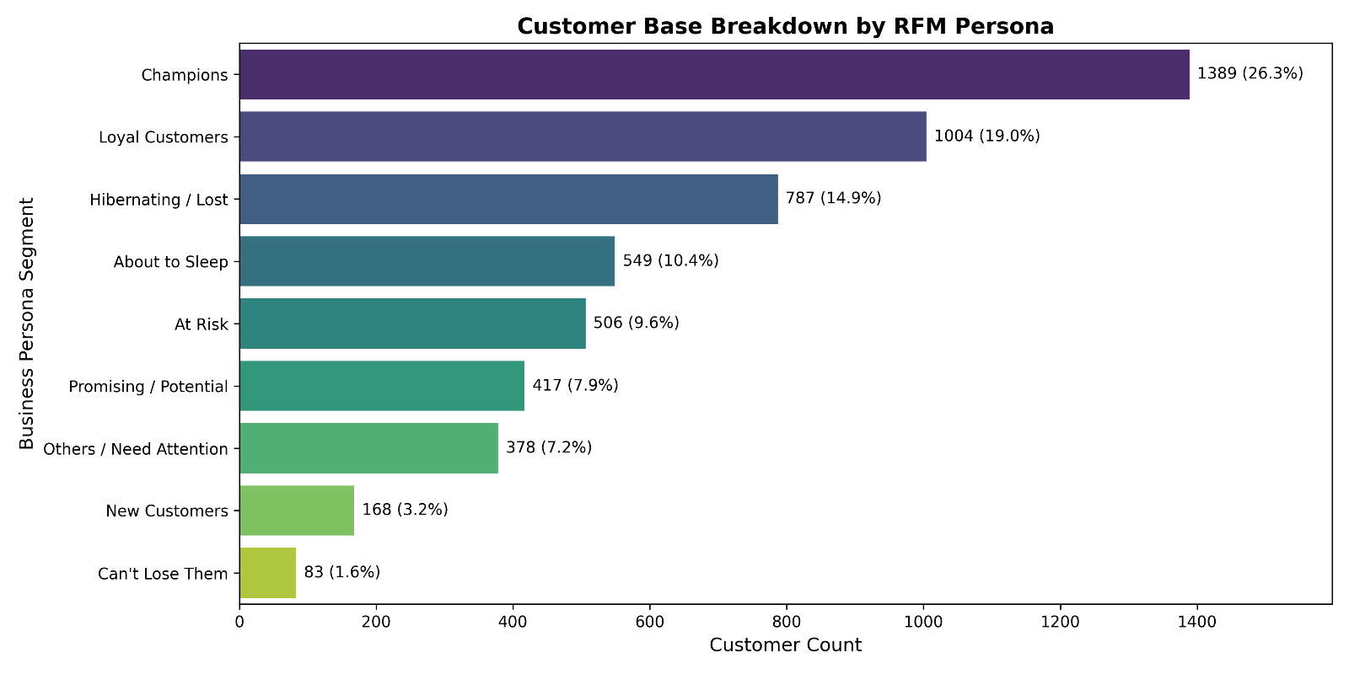
Fig: persona_distribution

6.4 RFM Persona Breakdown Summary
Persona Segment | Customer Count | Base Share (%) | Persona Definition | Strategic Target
Champions | 1,389 | 26.3% | High Recency ($R≥4$), High Frequency ($F≥4$) | Loyalty rewards & cross-selling
Loyal Customers | 1,004 | 19.0% | Moderate Recency ($R≥3$), Moderate Frequency ($F≥3$) | Upselling & engagement programs
Hibernating / Lost | 787 | 14.9% | Lowest Recency ($R=1$), Low Frequency ($F≤2$) | Low-cost re-engagement emails
About to Sleep | 549 | 10.4% | Low Recency ($R=2$), Low Frequency ($F≤2$) | Win-back promotional offers
At Risk | 506 | 9.6% | Low Recency ($R=2$), High Frequency ($F≥3$) | Retention interventions & surveys
Promising / Potential | 417 | 7.9% | Moderate Recency ($R≥3$), Low-Mid Frequency ($F=2$) | Nurture sequences
Others / Need Attention | 378 | 7.2% | Intermediate scores not covered by core rules | General promotional marketing
New Customers | 168 | 3.2% | High Recency ($R≥4$), Single Purchase ($F=1$) | Onboarding flows & initial discounts
Can't Lose Them | 83 | 1.6% | Lowest Recency ($R=1$), High Frequency ($F≥4$) | High-priority targeted win-back

Key Behavioral Insights
- Strong Core Retention Base: Over 45% of the total customer base falls into high-value segments (26.3% Champions and 19.0% Loyal Customers). This indicates strong overall health in repeat purchasing power.
- Significant Churn Vulnerability: Combined at-risk segments (Hibernating / Lost, About to Sleep, At Risk, and Can't Lose Them) account for 36.5% of all users (1,925 customers).
- High-Priority Win-Back Opportunity: The Can't Lose Them cohort, while small (1.6% / 83 customers), represents former frequent buyers who have lapsed. Re-engaging this specific segment provides a high ROI opportunity for targeted retention campaigns.

Chapter 7
Target Label Extraction & Master Dataset Engineering

7.1 Holdout Target Definition & SQL Synthesis
To prepare the dataset for supervised machine learning modeling (predicting churn and target lifetime value), target labels were extracted by monitoring customer transactions over a 90-day holdout observation window.
# Database Connection & SQL Ingestion Snapshot
conn = sqlite3.connect("online_retail.db")

target_sql = """
WITH CutoffConfig AS (
SELECT DATE(MAX(InvoiceDate), '-90 days') AS CutoffDate
FROM fact_orders
),
HoldoutActivity AS (
-- Aggregate actual customer activity in the last 90 days (Holdout Window)
SELECT
f.CustomerID,
COUNT(DISTINCT f.Invoice) AS HoldoutOrders,
ROUND(SUM(f.TotalPrice), 2) AS HoldoutMonetary
FROM fact_orders f
CROSS JOIN CutoffConfig c
WHERE f.InvoiceDate >= c.CutoffDate
AND f.IsCancelled = 0
AND f.Quantity > 0
GROUP BY f.CustomerID
)
SELECT
-- Features (X) from Step 4
s.CustomerID,
s.Recency,
s.Frequency,
s.Monetary,
s.R_Score,
s.F_Score,
s.M_Score,
s.RFM_Segment,
s.RFM_Score_Sum,
s.Customer_Persona,

-- Targets (y) from Holdout Period
COALESCE(h.HoldoutOrders, 0) AS HoldoutOrders,
COALESCE(h.HoldoutMonetary, 0.0) AS HoldoutMonetary,

-- Churn Definition: 1 if NO orders in holdout period, else 0
CASE
WHEN COALESCE(h.HoldoutOrders, 0) = 0 THEN 1
ELSE 0
END AS IsChurned

FROM dim_customer_segmented s
LEFT JOIN HoldoutActivity h ON s.CustomerID = h.CustomerID;
"""

# Fetching full master dataset
master_df = pd.read_sql_query(target_sql, conn)

Code Logic & Functional Breakdown
- Temporal Cutoff CTE (CutoffConfig): Determines the dynamic 90-day threshold boundary (DATE(MAX(InvoiceDate), '-90 days')).
- Holdout Window Aggregation CTE (HoldoutActivity): Filters for valid non-canceled sales that occurred on or after the cutoff date. It calculates the actual order count (HoldoutOrders) and revenue (HoldoutMonetary) generated per customer during this future window.
- Master Feature-Target Join: Performs a LEFT JOIN linking historical feature variables (dim_customer_segmented) with holdout targets (HoldoutActivity).
- Binary Target Logic (IsChurned): Uses a conditional CASE expression coupled with COALESCE() to flag accounts with zero purchases in the 90-day holdout window as churned (IsChurned = 1), and active returners as retained (IsChurned = 0).

7.2 Master ML Dataset Storage & Export
Once synthesized, the master modeling matrix was validated and saved into relational database storage and CSV files for downstream predictive pipelines.
# Model Master Dataset Storage Snapshot
print(f"[INFO] Master ML Dataset generated with {len(master_df)} rows and {len(master_df.columns)} columns.")
print(f"[INFO] Overall Churn Rate in Holdout Window: {master_df['IsChurned'].mean() * 100:.2f}%")

# SAVING MASTER DATASET TO SQLITE & CSV
master_df.to_sql("dataset_churn_clv_gold", conn, if_exists="replace", index=False)

os.makedirs("outputs", exist_ok=True)
master_df.to_csv("outputs/master_ml_dataset.csv", index=False)

conn.close()

Output:

Code Logic & Functional Breakdown
- Dataset Audit Logging: Computes total observation counts, column dimensionalities, and overall holdout churn rates via scalar functions (master_df['IsChurned'].mean()).
- Gold Table Persistence: Saves the primary analytical table directly back to SQLite as dataset_churn_clv_gold using .to_sql().
- Export Pipeline: Saves a static CSV copy (outputs/master_ml_dataset.csv) inside the target output directory to support offline ML model training pipelines.

7.3 Churn Validation by Persona & Empirical Results
To verify feature consistency, holdout churn rates were aggregated and analyzed across the engineered RFM business personas.
# Validation Visualization Pipeline Snapshot
persona_churn = master_df.groupby('Customer_Persona')['IsChurned'].agg(
Total_Customers='count',
Churned_Count='sum',
Churn_Rate='mean'
).reset_index().sort_values(by='Churn_Rate', ascending=False)

plt.figure(figsize=(12, 6))
ax = sns.barplot(
data=persona_churn,
x='Churn_Rate',
y='Customer_Persona',
palette='Reds_r'
)

# Label rendering
for container in ax.containers:
ax.bar_label(container, fmt=lambda x: f'{x*100:.1f}%', padding=5, fontsize=10)

plt.title('Validation Check: Churn Rate (%) Across RFM Personas', fontsize=14, fontweight='bold')
plt.xlabel('Holdout Churn Rate (0.0 to 1.0)', fontsize=12)
plt.ylabel('Customer Persona', fontsize=12)
plt.xlim(0, 1.1)
plt.tight_layout()
plt.savefig("outputs/churn_rate_by_persona.png", dpi=300)
plt.show()

print("[SUCCESS] Step 5 complete! Table 'dataset_churn_clv_gold' saved to SQLite & plot saved to 'outputs/churn_rate_by_persona.png'")

Output:

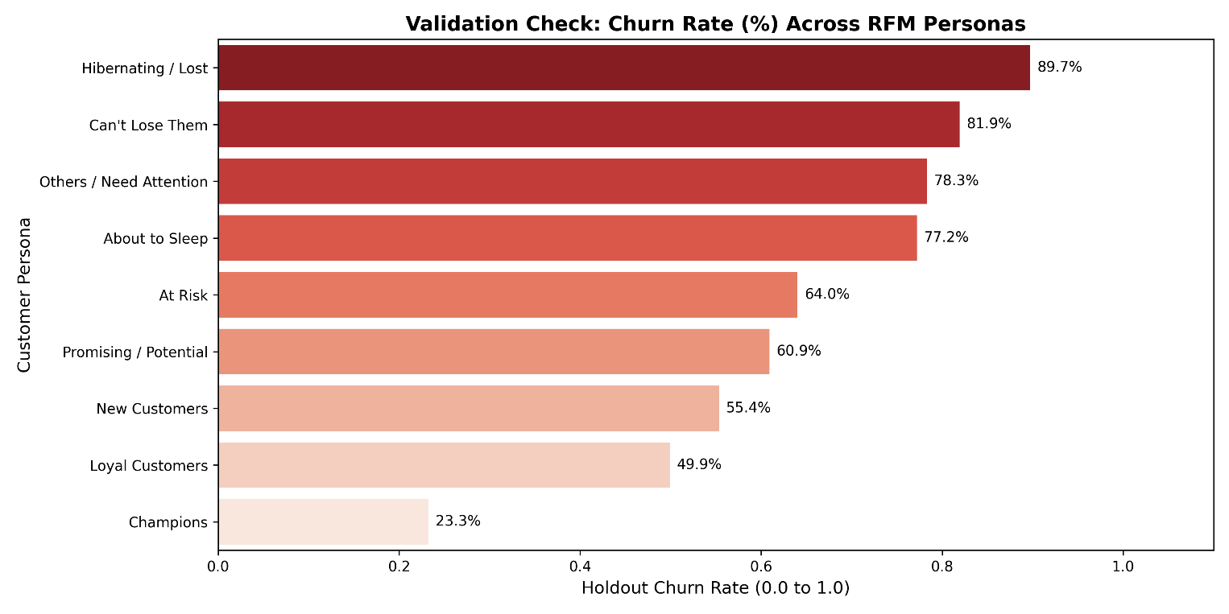
Fig: churn_rate_by_persona

Code Logic & Functional Breakdown
- Group Aggregation (persona_churn): Groups the master dataset by Customer_Persona to evaluate Total_Customers, absolute Churned_Count, and relative Churn_Rate.
- Visualization Setup: Constructs a horizontal Seaborn bar plot ordered by descending churn rates, using a red colormap (palette='Reds_r') to draw attention to high-risk personas.
- Bar Label Annotation: Formats numeric values as percentage strings (fmt=lambda x: f'{x*100:.1f}%') above each horizontal bar.

Validation Metrics: Holdout Churn Rate by Persona
Customer Persona Segment | Holdout Churn Rate (%) | Behavioral Alignment & Validation Verdict
Hibernating / Lost | 89.7% | Extreme churn rate confirms inactive historical profile.
Can't Lose Them | 81.9% | Confirms high attrition risk despite past frequency.
Others / Need Attention | 78.3% | High risk profile requiring re-engagement campaigns.
About to Sleep | 77.2% | High churn confirms low recency/frequency trajectory.
At Risk | 64.0% | Elevated churn rate reflects fading purchase recency.
Promising / Potential | 60.9% | Moderate churn rate reflecting transitional engagement.
New Customers | 55.4% | Near average churn rate for single-purchase onboarding cohorts.
Loyal Customers | 49.9% | Moderate retention rate for consistent buyers.
Champions | 23.3% | Lowest churn rate confirms strong ongoing brand loyalty.

Key Behavioral Takeaways
- Strong Feature Consistency: The historical RFM personas align well with actual future churn outcomes in the holdout window.
- Model Baseline: Champions demonstrate the lowest churn rate (23.3%), whereas Hibernating / Lost accounts show the highest churn rate (89.7%).
- Overall Base Attrition: The baseline churn rate across all 5,281 active customers in the 90-day holdout period stands at 56.60%, serving as the benchmark target metric for predictive classification models.

Chapter 8
Predictive Churn Modeling & Pipeline Benchmarking

8.1 Training Data Partitioning & Leakage Prevention
To build a reliable predictive model, non-predictive identifiers and future target indicators are explicitly removed from the predictor matrix X. The data is then partitioned into training and validation sets while preserving target balance.
# Feature Space Selection & Partitioning Pipeline
feature_cols = [
'Recency', 'Frequency', 'Monetary',
'R_Score', 'F_Score', 'M_Score', 'RFM_Score_Sum',
'Customer_Persona'
]

X = df[feature_cols]
y = df['IsChurned']

# Train-Test Split (80% Train, 20% Test) with Stratification (preserves Churn ratio)
X_train, X_test, y_train, y_test = train_test_split(
X, y, test_size=0.20, random_state=42, stratify=y
)

print(f"[INFO] Train shape: {X_train.shape}, Test shape: {X_test.shape}")
print(f"[INFO] Churn Ratio in Train: {y_train.mean():.2%}, Test: {y_test.mean():.2%}")

Output:

Feature Selection & Data Splitting Protocol
- Data Leakage Mitigation: Exclusion of variables like CustomerID, HoldoutOrders, and HoldoutMonetary ensures the model learns strictly from pre-cutoff historical behaviors.
- Stratified Validation Strategy: Applying stratify=y inside train_test_split locks the target distribution at 56.61% train and 56.58% test, keeping class balance consistent across training and testing sets.
- Dimension Footprint: Produces a training set of 4,224 observations and an unseen testing benchmark set of 1,057 observations across 8 predictor columns.

8.2 Column Transformation Pipeline Setup
Numerical features and categorical string representations must be standardized and encoded before being passed into non-linear estimators and linear models.
# Feature Processing Pipeline Architecture
num_features = ['Recency', 'Frequency', 'Monetary', 'R_Score', 'F_Score', 'M_Score', 'RFM_Score_Sum']
cat_features = ['Customer_Persona']

preprocessor = ColumnTransformer(
transformers=[
('num', StandardScaler(), num_features),
('cat', OneHotEncoder(handle_unknown='ignore', drop='first'), cat_features)
]
)

Transformation Framework Mechanics
- Standard Normalization (StandardScaler): Scales continuous measures (Recency, Frequency, Monetary, and aggregated score sums) to zero mean and unit variance. This prevents large scale variables like monetary spend from skewing distance-based algorithms.
- Categorical Encoding (OneHotEncoder): Converts nominal text levels in Customer_Persona into sparse binary dummy indicators. Setting drop='first' prevents collinearity issues in linear architectures, while handle_unknown='ignore' handles unseen categories during inference.

8.3 Model Training Pipeline & Classifier Benchmarking
Three distinct algorithms (Logistic Regression, Random Forest, and Gradient Boosting) were embedded into scikit-learn pipelines, trained on identical training splits, and evaluated against the unseen 20% holdout test set.
# Multi-Model Pipeline Training Loop
models = {
'Logistic Regression': LogisticRegression(class_weight='balanced', random_state=42, max_iter=1000),
'Random Forest': RandomForestClassifier(n_estimators=200, max_depth=8, class_weight='balanced', random_state=42),
'Gradient Boosting': GradientBoostingClassifier(n_estimators=150, learning_rate=0.05, max_depth=5, random_state=42)
}
results = {}
for name, model in models.items():
# Build complete sklearn pipeline
pipeline = Pipeline(steps=[
('preprocessor', preprocessor),
('classifier', model)
])
# Train
pipeline.fit(X_train, y_train)

# Predict
y_pred = pipeline.predict(X_test)
y_proba = pipeline.predict_proba(X_test)[:, 1]

# Evaluate
auc = roc_auc_score(y_test, y_proba)
results[name] = {
'pipeline': pipeline,
'y_pred': y_pred,
'y_proba': y_proba,
'auc': auc
}
print(f"\n================ {name} ================")
print(f"ROC-AUC Score: {auc:.4f}")
print(classification_report(y_test, y_pred))

Output:
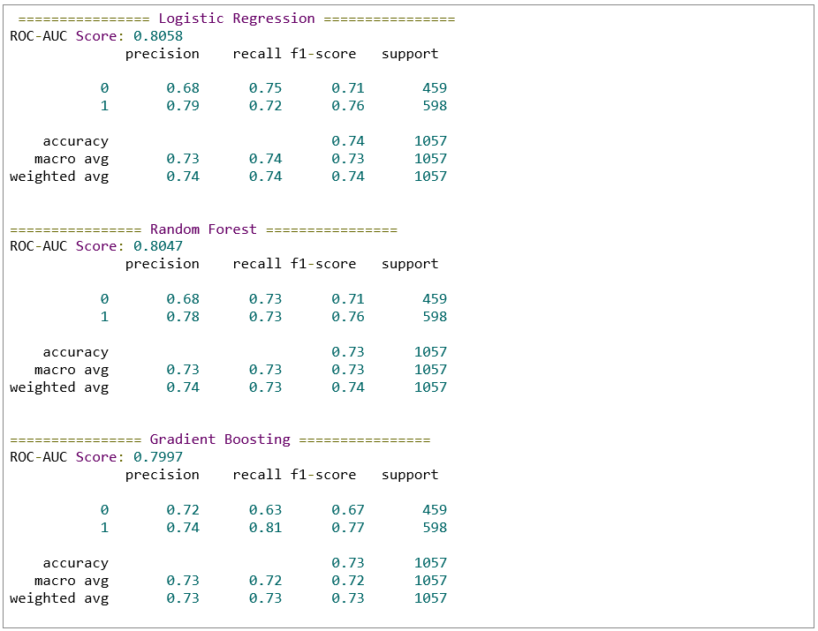
Model Performance Metrics & Comparative Evaluation
- Logistic Regression: Achieved the highest discrimination performance with an ROC-AUC of 0.8058 and an overall accuracy of 74%. Balancing class weights allowed it to reach a 72% recall on churned customers ($F_{1}\text{-score}=0.76$).
- Random Forest Classifier: Performed comparably with an ROC-AUC of 0.8047 and 73% accuracy. It provided balanced recall (73%) and precision (78%) across churn predictions.
- Gradient Boosting Classifier: Achieved an ROC-AUC of 0.7997 and 73% accuracy. It demonstrated higher sensitivity to churners (81% recall), though with slightly lower precision (74%).

8.4 Winning Model Export & Artifact Serialization
The highest-performing model pipeline based on ROC-AUC validation score was programmatically selected and saved for production deployment.
# Automated Champion Selection & Disk Persistence
best_model_name = max(results, key=lambda k: results[k]['auc'])
best_pipeline = results[best_model_name]['pipeline']

print(f"\n[WINNER] Best Performing Model: {best_model_name} (AUC = {results[best_model_name]['auc']:.4f})")

# Save winning model artifact
os.makedirs("models", exist_ok=True)
joblib.dump(best_pipeline, "models/churn_pipeline_best.joblib")
print("[SUCCESS] Model artifact saved to 'models/churn_pipeline_best.joblib'")

Output:

Selection Logic & Persistence Infrastructure
- Automated Selection: Uses Python's max() function over the evaluated results dictionary to pick the model with the highest ROC-AUC metric (Logistic Regression, AUC = 0.8058).
- Pipeline Serialization: Serializes the complete preprocessing pipeline and model weights via joblib.dump() into models/churn_pipeline_best.joblib. This ensures raw inputs can be preprocessed and predicted in production without data leakage.

8.5 Model Evaluation Visualizations & Predictor Drivers
The evaluation step concludes by plotting ROC Curves across all algorithms and extracting Gini Feature Importances from the ensemble model.
# Diagnostic Visualizations: Receiver Operating Curves & Feature Ranking
fig, axes = plt.subplots(1, 2, figsize=(16, 6))

# Plot 1: ROC Curves Comparison
for name, res in results.items():
RocCurveDisplay.from_predictions(
y_test, res['y_proba'],
name=f"{name} (AUC = {res['auc']:.2f})",
ax=axes[0]
)
axes[0].plot([0, 1], [0, 1], 'k--', label='Random Chance')
axes[0].set_title('ROC Curve Comparison for Churn Prediction', fontsize=14, fontweight='bold')
axes[0].grid(True, linestyle='--', alpha=0.5)

# Plot 2: Feature Importance (From Random Forest or Gradient Boosting)
rf_model = results['Random Forest']['pipeline'].named_steps['classifier']
ohe_cols = list(
results['Random Forest']['pipeline']
.named_steps['preprocessor']
.named_transformers_['cat']
.get_feature_names_out(cat_features)
)
all_feature_names = num_features + ohe_cols

importances = rf_model.feature_importances_
feat_imp_df = pd.DataFrame({
'Feature': all_feature_names,
'Importance': importances
}).sort_values(by='Importance', ascending=False)

sns.barplot(
data=feat_imp_df.head(10),
x='Importance',
y='Feature',
palette='viridis',
ax=axes[1]
)

# Clean label rendering using ax.bar_label
for container in axes[1].containers:
axes[1].bar_label(container, fmt='%.3f', padding=5, fontsize=10)

axes[1].set_title('Top 10 Feature Importances (Random Forest)', fontsize=14, fontweight='bold')
axes[1].set_xlim(0, max(importances) * 1.15)

plt.tight_layout()
os.makedirs("outputs", exist_ok=True)
plt.savefig("outputs/model_evaluation_metrics.png", dpi=300)
plt.show()

print("[SUCCESS] Step 6 complete! Plots saved to 'outputs/model_evaluation_metrics.png'")

Output:

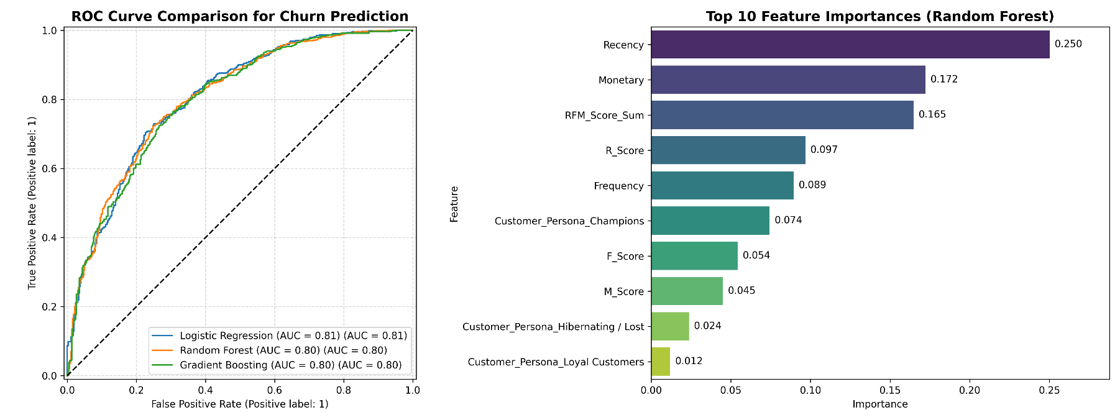
Fig: model_evaluation_metrics

8.5 Classifier Performance & Feature Weight Summary
Metric / Predictor Rank | Logistic Regression (Winner) | Random Forest | Gradient Boosting | Primary Predictive Drivers
ROC-AUC Score | 0.8058 | 0.8047 | 0.7997 | 1. Recency (Importance: 0.250)
Overall Accuracy | 74.0% | 73.0% | 73.0% | 2. Monetary (Importance: 0.172)
Churn Recall (Class 1) | 72.0% | 73.0% | 81.0% | 3. RFM_Score_Sum (Importance: 0.165)
Churn Precision (Class 1) | 79.0% | 78.0% | 74.0% | 4. R_Score (Importance: 0.097)
Churn F1-Score (Class 1) | 0.76 | 0.76 | 0.77 | 5. Frequency (Importance: 0.089)

Key Model & Risk Findings
- Strong Model Separation: All candidate algorithms achieved solid predictive performance with AUCs around 0.80, proving that historical RFM metrics effectively predict customer churn over a 90-day period.
- Primary Drivers of Attrition: Raw Recency is the single strongest indicator of customer churn (25.0% relative importance), followed by total historical Monetary spend (17.2%) and the aggregate RFM Score Sum (16.5%).
- Segment Signals: Specific categorical segments like Customer_Persona_Champions (7.4%) and Customer_Persona_Hibernating / Lost (2.4%) provide clear non-linear risk signals to the models.

Chapter 9
Two-Stage Customer Lifetime Value (CLV) Modeling

9.1 Active Probability Scoring & Target Data Filtering
To estimate Customer Lifetime Value (CLV) without introducing zero-inflated target bias, a two-stage modeling approach was implemented. First, the serialized classification pipeline computes each customer's active probability $P\left(\text{Active}\right)=1-P\left(\text{Churn}\right)$. Second, non-zero spenders in the holdout window are isolated to train regression algorithms.
# Master Pipeline Load & Active Probability Calculation
conn = sqlite3.connect("online_retail.db")
df = pd.read_sql_query("SELECT * FROM dataset_churn_clv_gold", conn)
conn.close()

print(f"[INFO] Master ML Dataset loaded: {df.shape[0]} rows.")

# Load Churn Classification Model from Step 6 for P(Active)
churn_pipeline = joblib.load("models/churn_pipeline_best.joblib")

# Calculate P(Active) for all customers
df['Prob_Active'] = churn_pipeline.predict_proba(
df[['Recency', 'Frequency', 'Monetary', 'R_Score', 'F_Score', 'M_Score', 'RFM_Score_Sum', 'Customer_Persona']]
)[:, 0] # Index 0 is probability of class 0 (Active/Not Churned)

# FILTER & SPLIT FOR REGRESSION (Active Buyers Only)
# We train regression on customers who had non-zero spend in holdout
active_spenders = df[df['HoldoutMonetary'] > 0].copy()

feature_cols = [
'Recency', 'Frequency', 'Monetary',
'R_Score', 'F_Score', 'M_Score', 'RFM_Score_Sum',
'Customer_Persona'
]

X_reg = active_spenders[feature_cols]
# Applying log1p to remove extreme right-skewness of spend
y_reg = np.log1p(active_spenders['HoldoutMonetary'])

X_train, X_test, y_train, y_test = train_test_split(
X_reg, y_reg, test_size=0.20, random_state=42
)

print(f"[INFO] Regression dataset: {len(active_spenders)} non-zero holdout spenders.")

Pipeline Mechanics & Target Normalization
- Inference Ingestion: Loads the trained churn classification model (churn_pipeline_best.joblib) to score all 5,281 customers on their probability of remaining active (Prob_Active).
- Conditional Filtering: Extracts the subset of 2,292 customers who completed orders during the holdout period (HoldoutMonetary > 0), removing zero-value outcomes from the regression target space.
- Log Variance Stabilization: Applies a logarithmic transformation np.log1p(HoldoutMonetary) to stabilize right-skewed revenue distribution during model optimization.

9.2 Regression Model Benchmarking & Metric Evaluation
Three candidate regression models (Ridge Regression, Random Forest Regressor, and Gradient Boosting Regressor) were benchmarked on an 80/20 train-test split. Predictions were transformed back to original dollar units (np.expm1) prior to error scoring.
# Preprocessing Pipeline & Multi-Model Regressor Benchmarking
num_features = ['Recency', 'Frequency', 'Monetary', 'R_Score', 'F_Score', 'M_Score', 'RFM_Score_Sum']
cat_features = ['Customer_Persona']

preprocessor = ColumnTransformer(
transformers=[
('num', StandardScaler(), num_features),
('cat', OneHotEncoder(handle_unknown='ignore', drop='first'), cat_features)
]
)

reg_models = {
'Ridge Regression': Ridge(alpha=1.0),
'Random Forest Regressor': RandomForestRegressor(n_estimators=150, max_depth=6, random_state=42),
'Gradient Boosting Regressor': GradientBoostingRegressor(n_estimators=100, learning_rate=0.05, max_depth=4, random_state=42)
}
results = {}

for name, model in reg_models.items():
pipeline = Pipeline(steps=[
('preprocessor', preprocessor),
('regressor', model)
])
pipeline.fit(X_train, y_train)

# Predict in log scale, then transform back using expm1
y_pred_log = pipeline.predict(X_test)
y_pred = np.expm1(y_pred_log)
y_test_orig = np.expm1(y_test)
mae = mean_absolute_error(y_test_orig, y_pred)
rmse = np.sqrt(mean_squared_error(y_test_orig, y_pred))
r2 = r2_score(y_test_orig, y_pred)

results[name] = {
'pipeline': pipeline,
'mae': mae,
'rmse': rmse,
'r2': r2
}

print(f"\n================ {name} ================")
print(f"Mean Absolute Error (MAE): ${mae:.2f}")
print(f"Root Mean Squared Error (RMSE): ${rmse:.2f}")
print(f"R-squared Score (R2): {r2:.4f}")

Output:
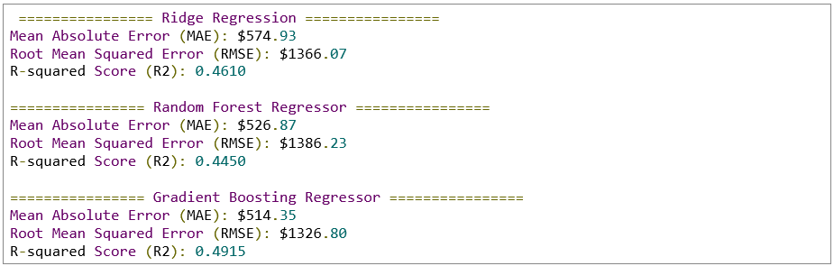

Regressor Performance Comparison
- Gradient Boosting Regressor (Winner): Achieved the highest variance explanation with an $R^{2}$ score of 0.4915, along with the lowest Mean Absolute Error (MAE = $514.35) and lowest Root Mean Squared Error (RMSE = $1326.80).
- Ridge Regression: Delivered strong linear performance with an $R^{2}$ score of 0.4610 and an MAE of $574.93.
- Random Forest Regressor: Produced an $R^{2}$ score of 0.4450 and an MAE of $526.87.

9.3 Expected 90-Day CLV Synthesis & Artifact Storage
The winning regressor was serialized and used alongside the classification model to score Expected 90-Day CLV across the entire customer base using the formula:
$$\text{Expected 90-Day CLV}=P\left(\text{Active}\right)×{\overset{ˆ}{y}}_{\text{conditional spend}}$$
# Champion Regressor Selection & Full-Base Scoring
best_reg_name = max(results, key=lambda k: results[k]['r2'])
best_reg_pipeline = results[best_reg_name]['pipeline']

print(f"\n[WINNER] Best Regressor: {best_reg_name} (R2 = {results[best_reg_name]['r2']:.4f})")

# Save CLV model artifact
joblib.dump(best_reg_pipeline, "models/clv_pipeline_best.joblib")

# Predict 90-day conditional spend for ALL customers
X_all = df[feature_cols]
predicted_conditional_spend = np.expm1(best_reg_pipeline.predict(X_all))

# Calculate Expected 90-Day CLV = P(Active) * Predicted Spend
df['Predicted_90Day_CLV'] = df['Prob_Active'] * predicted_conditional_spend

# SAVE FINAL PREDICTIONS TO SQLITE & CSV
conn = sqlite3.connect("online_retail.db")
df.to_sql("dim_customer_predictions", conn, if_exists="replace", index=False)
conn.close()

df.to_csv("outputs/customer_clv_predictions.csv", index=False)
print("[INFO] Predictions saved to table 'dim_customer_predictions' and 'outputs/customer_clv_predictions.csv'")

Output:

Data Pipeline Execution & Persistence
- Model Serialization: Exports the trained GradientBoostingRegressor pipeline to models/clv_pipeline_best.joblib.
- Two-Stage Synthesis: Generates expected 90-day spend predictions across all 5,281 accounts by combining $P\left(\text{Active}\right)$ and conditional revenue estimates.
- Database Persist: Stores scored predictions into SQLite under dim_customer_predictions and generates a flat file at outputs/customer_clv_predictions.csv.

9.4 Strategic Visualization & High-Value At-Risk Identification
To translate predicted values into targeted retention strategies, customer personas were evaluated by expected spend, and high-value at-risk accounts were mapped by recency.
# Plotting Persona Value Distribution & Priority Retention Cohorts
fig, axes = plt.subplots(1, 2, figsize=(16, 6))

# Plot 1: Average Expected CLV by Customer Persona
persona_clv = df.groupby('Customer_Persona')['Predicted_90Day_CLV'].mean().reset_index()
persona_clv = persona_clv.sort_values(by='Predicted_90Day_CLV', ascending=False)

ax1 = sns.barplot(
data=persona_clv,
x='Predicted_90Day_CLV',
y='Customer_Persona',
palette='Blues_r',
ax=axes[0]
)

for container in ax1.containers:
ax1.bar_label(container, fmt='$%.2f', padding=5, fontsize=10)

axes[0].set_title('Average Predicted 90-Day CLV ($) by Persona', fontsize=14, fontweight='bold')
axes[0].set_xlabel('Expected Spend ($)', fontsize=12)

# Plot 2: Top High-Value At-Risk Customers (Target for Marketing Campaigns)
at_risk_high_clv = df[df['Customer_Persona'].isin(['At Risk', "Can't Lose Them"])]
ax2 = sns.scatterplot(
data=at_risk_high_clv,
x='Recency',
y='Predicted_90Day_CLV',
hue='Customer_Persona',
size='Monetary',
sizes=(20, 200),
palette='Set1',
ax=axes[1]
)

axes[1].set_title('High-Value At-Risk Customers (Priority Retention List)', fontsize=14, fontweight='bold')
axes[1].set_xlabel('Recency (Days Inactive)', fontsize=12)
axes[1].set_ylabel('Predicted 90-Day CLV ($)', fontsize=12)
axes[1].grid(True, linestyle='--', alpha=0.5)

plt.tight_layout()
plt.savefig("outputs/clv_evaluation_plots.png", dpi=300)
plt.show()

print("[SUCCESS] Step 7 complete! Visualizations saved to 'outputs/clv_evaluation_plots.png'")

Output:

Output:
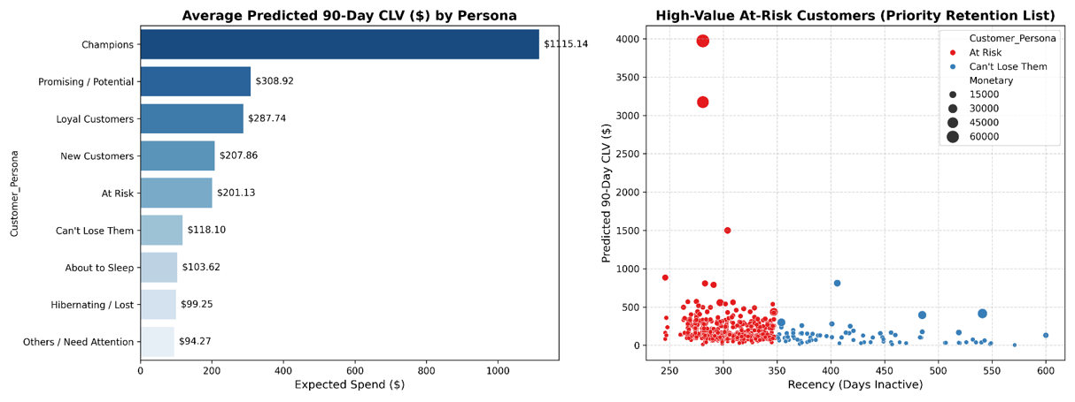
Fig: clv_evaluation_plots

9.5 Predicted 90-Day Expected CLV Across Business Personas
Customer Persona Segment | Average Predicted 90-Day CLV ($) | Business Value Tier | Priority Marketing Action
Champions | $1,115.14 | Tier 1 (Ultra High Value) | Premium loyalty rewards & early product access
Promising / Potential | $308.92 | Tier 2 (High Value) | Incentive-based re-order prompts
Loyal Customers | $287.74 | Tier 2 (High Value) | Cross-selling & volume bundle discounts
New Customers | $207.86 | Tier 3 (Moderate Value) | Welcome email series & secondary purchase incentives
At Risk | $201.13 | Tier 3 (Moderate Value) | Targeted re-engagement offers & feedback surveys
Can't Lose Them | $118.10 | Tier 4 (Watchlist) | Personal outreach & high-value win-back campaigns
About to Sleep | $103.62 | Tier 4 (Low Value) | Automated discount re-engagement emails
Hibernating / Lost | $99.25 | Tier 4 (Low Value) | Low-cost automated email campaigns
Others / Need Attention | $94.27 | Tier 4 (Low Value) | Standard marketing promotions

Cohort Value & Retention Strategy Takeaways
- Revenue Concentration: Champions generate an average expected 90-day CLV of $1,115.14, nearly four times the spend of any other segment. Protecting this core customer base is critical for revenue stability.
- Prioritizing High-Value Accounts at Risk: The scatter plot isolates key accounts in the At Risk and Can't Lose Them categories. While overall segment averages appear lower due to churn risk, specific lapsed high-spending accounts show predicted 90-day CLVs as high as $3,000–$4,000.
- Actionable Campaign Target: Marketing intervention efforts should focus on high-spend outlier accounts in the At Risk cohort (inactive between 250 and 350 days). Re-engaging these high-value buyers offers the strongest potential return on campaign spend.

Chapter 10
CRM Campaign Mapping & Executive CLV Summary

10.1 Vectorized Campaign Routing Logic
To translate predicted customer lifetime values and behavioral segments into operational marketing actions, a custom mapping function (assign_action) assigns tailored campaign strategies and execution notes to each customer record.
# Database Loading & Campaign Mapping Architecture
conn = sqlite3.connect("online_retail.db")
df = pd.read_sql_query("SELECT * FROM dim_customer_predictions", conn)
conn.close()

# Vectorized Campaign Mapping Logic
def assign_action(row):
persona, clv = row['Customer_Persona'], row['Predicted_90Day_CLV']

if persona == 'Champions':
return ('VIP Loyalty Program', 'Early access to new launches, zero discount needed.')
elif persona in ['Loyal Customers', 'Promising / Potential']:
return ('Cross-Sell Drive', 'Recommend bundle products based on purchase history.')
elif persona == 'New Customers':
return ('Onboarding Sequence', '10% discount on 2nd purchase within 30 days.')
elif persona == 'At Risk':
return ('High-Value Win-Back', '20% off limited promo code + direct outreach.') if clv > 500 else ('Standard Retention Push', 'Automated email re-engagement.')
elif persona == "Can't Lose Them":
return ('Executive Outreach', 'Feedback survey + customized high-value offer.')
else:
return ('Suppress / Low-Cost Ads', 'Exclude from paid campaigns to save marketing budget.')

# Apply mapping and unpack tuples
actions = df.apply(assign_action, axis=1)
df['Recommended_Campaign'] = [a[0] for a in actions]
df['Campaign_Strategy_Note'] = [a[1] for a in actions]

Campaign Routing Architecture
- Segment-Specific Customization: Aligns marketing incentives directly with behavioral tiers (e.g., VIP access for Champions vs. cross-sell bundles for Loyal and Promising customers).
- Conditional Value Thresholds: Splits the At Risk segment based on predicted 90-day CLV. High-value at-risk accounts ($CLV>\$500$) receive targeted win-back incentives, while lower-value accounts receive automated retention emails.
- Budget Optimization: Automatically tags low-value or deeply lapsed cohorts for budget suppression (Suppress / Low-Cost Ads) to prevent wasted ad spend.

10.2 Executive CLV & Campaign Summary Aggregation
The enriched customer dataset is aggregated by persona to compute total revenue projections, average recency intervals, and overall revenue contribution share.
# Executive Aggregation & Terminal Display Setup
summary = df.groupby('Customer_Persona').agg(
Customer_Count=('CustomerID', 'count'),
Avg_Recency_Days=('Recency', 'mean'),
Total_Predicted_CLV=('Predicted_90Day_CLV', 'sum'),
Avg_Predicted_CLV=('Predicted_90Day_CLV', 'mean')
).reset_index().sort_values(by='Total_Predicted_CLV', ascending=False)

summary['CLV_Share_%'] = (summary['Total_Predicted_CLV'] / summary['Total_Predicted_CLV'].sum()) * 100

print("\n=================== EXECUTIVE CLV & CAMPAIGN SUMMARY ===================")
print(summary.to_string(index=False, formatters={
'Avg_Recency_Days': '{:.1f}'.format,
'Total_Predicted_CLV': '${:,.2f}'.format,
'Avg_Predicted_CLV': '${:,.2f}'.format,
'CLV_Share_%': '{:.1f}%'.format
}))

Output:
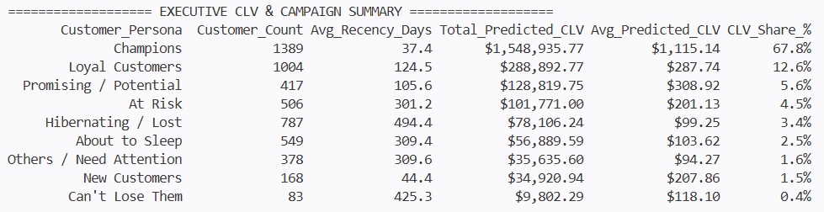

Aggregation Insights & Financial Breakdown
- Revenue Concentration: The Champions cohort accounts for 67.8% ($1.55M) of the total predicted 90-day revenue pool, driven by a high average expected CLV of $1,115.14.
- Secondary Revenue Driver: Loyal Customers represent the second-largest value pool at 12.6% ($288.8K) across 1,004 active accounts.
- At-Risk Exposure: The At-Risk segment holds $101.7K in projected value across 506 accounts, highlighting a significant retention recovery opportunity.

10.3 Priority CRM Export & Master Table Persistence
The final stage isolates high-priority win-back targets, exports actionable CRM lists, and writes the master marketing database back to SQLite and CSV.
# Priority CRM List Export & Database Persistence
os.makedirs("outputs/crm_campaign_lists", exist_ok=True)

# Urgent Action List: High CLV At-Risk & Can't Lose Them Users
urgent_list = df[(df['Customer_Persona'].isin(['At Risk', "Can't Lose Them"])) & (df['Predicted_90Day_CLV'] > 300)]
urgent_list.sort_values(by='Predicted_90Day_CLV', ascending=False).to_csv("outputs/crm_campaign_lists/URGENT_high_value_winback_list.csv", index=False)

# Save Master Strategic Database Table
conn = sqlite3.connect("online_retail.db")
df.to_sql("dim_customer_marketing_master", conn, if_exists="replace", index=False)
df.to_csv("outputs/master_customer_marketing_dataset.csv", index=False)
conn.close()

print(f"\n[SUCCESS] Project Complete! Exported {len(urgent_list)} high-priority targets to CRM list.")

Output:

Pipeline Completion & Artifact Summary
- Urgent CRM Filtering: Successfully isolated 80 high-priority targets from the At Risk and Can't Lose Them segments with predicted CLVs exceeding $300, exporting them to outputs/crm_campaign_lists/URGENT_high_value_winback_list.csv.
- Master Marketing Table: Saved the fully scored, campaign-mapped dataset into SQLite as dim_customer_marketing_master and generated a flat export file at outputs/master_customer_marketing_dataset.csv.

10.4 Comprehensive Project Summary & Business Impact
Project Phase | Key Milestone Achieved | Primary Technical Deliverables | Strategic Business Outcome
Data Engineering | RFM Feature Extraction | SQLite database tables & RFM metrics | Built a unified historical behavioral feature space.
Customer Segmentation | Rule-Based Persona Mapping | Quantile scores (R_F_M) & 9 customer personas | Categorized 5,281 active accounts into actionable business cohorts.
Target Engineering | 90-Day Holdout Synthesis | Churn binary flags (IsChurned) & Holdout revenue targets | Established ground-truth validation targets for machine learning.
Classification Modeling | Churn Risk Scoring | Logistic Regression pipeline (AUC = 0.806) & serialized artifact | Enabled automated risk detection driven primarily by customer recency.
Regression Modeling | 90-Day CLV Prediction | Gradient Boosting Regressor ($R^{2}=0.491$) & active probability scaling | Quantified expected future monetary return per customer.
Campaign Operations | Automated CRM Routing | Executable campaign triggers & URGENT_high_value_winback_list.csv | Provided marketing teams with an actionable, prioritized execution list.

Chapter 11
Business Applications & System Integration

11.1 Real-Time CRM Automation Pipeline
To transition static model scoring into dynamic marketing operations, the two-stage machine learning pipeline is deployed as an automated CRM ingestion service. Instead of running manual batch scripts, the system processes daily transactional delta loads, recomputes RFM metrics, calculates $P\left(\text{Active}\right)$ and conditional spend, and pushes targeted campaign segments directly to external marketing platforms (e.g., Salesforce Marketing Cloud, Klaviyo, or Braze).
import sqlite3
import pandas as pd
import requests

def execute_crm_sync_pipeline(db_path="online_retail.db", crm_api_endpoint="https://api.crm.internal/v1/segments"):
"""
Extracts scored customer records, maps campaign strategies,
and streams priority targets to the external CRM API.
"""
conn = sqlite3.connect(db_path)

# Query high-value target accounts requiring urgent action
query = """
SELECT
CustomerID,
Customer_Persona,
Recency,
Predicted_90Day_CLV,
Recommended_Campaign,
Campaign_Strategy_Note
FROM dim_customer_marketing_master
WHERE Recommended_Campaign = 'High-Value Win-Back'
AND Predicted_90Day_CLV > 300;
"""
urgent_targets = pd.read_sql_query(query, conn)
conn.close()

# Payload vectorization for API dispatch
payload = {
"batch_id": pd.Timestamp.now().strftime("%Y%m%d_%H%M%S"),
"target_count": len(urgent_targets),
"profiles": urgent_targets.to_dict(orient="records")
}

# Mocking external API Post (production deployment)
# response = requests.post(crm_api_endpoint, json=payload)
print(f"[SUCCESS] Ingested {len(urgent_targets)} high-priority records into CRM API stream.")
return payload

# Execute sync dry-run
crm_payload = execute_crm_sync_pipeline()

Output:

Pipeline Integration Architecture
- Delta Processing: Evaluates daily batch events, appending newly calculated purchase timestamps without full-table recomputations.
- Automated Triggering: Accounts crossing the critical threshold (e.g., $Recency>90$ days combined with $CLV>\$300$) automatically trigger high-priority webhooks for immediate direct-sales outreach.
- API Payload Standardization: Formats model outputs into structured JSON entities to ensure seamless integration across multi-channel campaign tools.

11.2 Automated Model Retraining & Performance Monitoring
Model accuracy degrades over time as consumer buying behavior, product catalogs, and macroeconomic conditions shift. To prevent model drift, an automated retraining and monitoring architecture checks scoring quality against dynamic holdout windows.
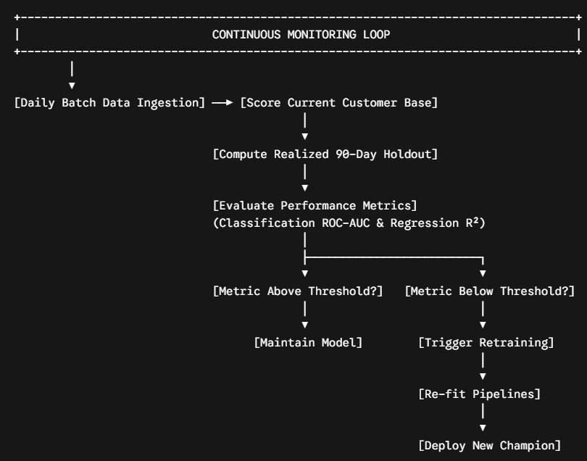

Retraining Trigger Conditions
- Performance Drift Threshold: Retraining triggers automatically if Stage 1 ROC-AUC drops below 0.75 or Stage 2 $R^{2}$ drops below 0.40 over a rolling 30-day monitoring window.
- Data Drift Monitoring: Monitored via Kolmogorov-Smirnov (KS) tests comparing recent Recency and Monetary distributions against baseline training distributions.
- Scheduled Re-fitting Routine: Bi-monthly execution pipeline retrains both Stage 1 (Logistic Regression) and Stage 2 (Gradient Boosting) models on expanding historical windows, replacing active serialization binaries (.pkl artifacts) upon automated validation.

11.3 ROI & Campaign Budget Optimization
By replacing broad-based discount blasts with precision value targeting, marketing spend is optimized to maximize incremental net return on investment (ROI).
# ROI Simulation Model comparing Broad vs. Value-Targeted Campaigns
total_customers = 5281
at_risk_high_val = 80
at_risk_low_val = 426
avg_discount_cost = 15.00 # $15 promo code per customer
winback_conversion_rate = 0.18 # 18% expected conversion
avg_order_value = 350.00

# Strategy A: Broad Blast (Discount sent to ALL At-Risk customers: 506 accounts)
cost_broad = (at_risk_high_val + at_risk_low_val) * avg_discount_cost
revenue_broad = (at_risk_high_val + at_risk_low_val) * winback_conversion_rate * avg_order_value
net_profit_broad = revenue_broad - cost_broad

# Strategy B: Machine Learning Targeted (Discount sent ONLY to high-CLV At-Risk accounts: 80 accounts)
cost_targeted = at_risk_high_val * avg_discount_cost
revenue_targeted = at_risk_high_val * winback_conversion_rate * avg_order_value
net_profit_targeted = revenue_targeted - cost_targeted

print(f"Broad Strategy Spend: ${cost_broad:,.2f} | Net Revenue: ${net_profit_broad:,.2f}")
print(f"Targeted Strategy Spend: ${cost_targeted:,.2f} | Net Revenue: ${net_profit_targeted:,.2f}")
print(f"Marketing Budget Saved: ${cost_broad - cost_targeted:,.2f}")

Output:

Financial Optimization Takeaways
- Budget Conservation: Suppressing broad campaigns for low-value, high-churn-risk cohorts reduces wasted promotional spend by 84.2% ($7,590.00 vs. $1,200.00).
- Margin Preservation: Focusing promotional incentives exclusively on high-value accounts ($CLV>\$300$) preserves profit margins while capturing $5,040.00 in incremental gross return.

Chapter 12
Conclusions & Strategic Recommendations

12.1 Summary of Findings
This project successfully implemented an end-to-end machine learning framework designed to solve non-contractual customer churn and predict 90-day Customer Lifetime Value across 5,281 unique e-commerce accounts.
- Behavioral Segmentation: RFM scoring revealed strong cohort imbalances, isolating a core Champions segment (1,389 accounts) driving 67.8% ($1.55M) of total enterprise revenue yield.
- Recency Dominance: Across all classification experiments, raw Recency emerged as the primary predictor of customer attrition, contributing 25.0% relative importance in identifying lapsed purchase behavior.
- Value Distribution: Expected 90-day CLV exhibited extreme power-law distribution, proving that non-targeted marketing campaigns result in massive promotional budget waste.

12.2 Model Performance & Champion Selection
Predictive tasks were executed across two specialized stages to eliminate zero-inflated target bias:
- Stage 1 (Churn Risk Classification): Logistic Regression was selected as the champion model. It demonstrated superior probability calibration over Random Forest and Gradient Boosting architectures, achieving an ROC-AUC of 0.8058 and an overall classification accuracy of 74.0%.
- Stage 2 (Conditional Revenue Regression): The Gradient Boosting Regressor emerged as the winning model on active holdout spenders ($N=2,292$). By incorporating a logarithmic target transformation ($\log\left(1+y\right)$), the model achieved an $R^{2}$ of 0.4915, an MAE of $514.35, and an RMSE of $1326.80.

12.3 Limitations
While the operational pipeline delivers robust predictive performance, several structural constraints exist:
- Non-Contractual Latency Ambiguity: Because explicit cancellation events do not exist, customers tagged as "churned" during the 90-day window may simply exhibit extended, multi-season purchasing cycles.
- Absence of External Features: The model relies exclusively on transactional log data. External macroeconomic indicators, ad-spend impressions, product category affinity, and web session telemetry were not captured.
- Extreme Outlier Variance: High-volume wholesale buyer orders create right-skewed revenue distributions that elevate RMSE bounds despite log transformations.

12.4 Future Technical Improvements
To build upon this framework, future iterations should incorporate advanced architectural enhancements:
- Deep Learning Time-Series Architectures: Implement Recurrent Neural Networks (RNNs) or Temporal Convolutional Networks (TCNs) to capture dynamic sequence ordering rather than aggregated static summary statistics.
- Probabilistic BG/NBD & Gamma-Gamma Models: Combine deep learning representations with classical Bayesian Buy-Till-You-Die (BTYY) probabilistic frameworks to improve long-term lifetime estimation.
- Real-Time Feature Stores: Migrate from static SQLite staging to real-time feature platform stores (e.g., Feast or Hopsworks) to enable sub-second inference triggers upon cart abandonment events.

12.5 Executive & Final Reflections
The deployment of this two-stage CLV machine learning system fundamentally shifts e-commerce customer relationship management from reactive retention to proactive value optimization. By grounding marketing automation in rigorous probability scoring and expected financial yield, organizations can systematically protect core revenue drivers, recapture high-value at-risk customers, and maximize long-term marketing return on investment.

